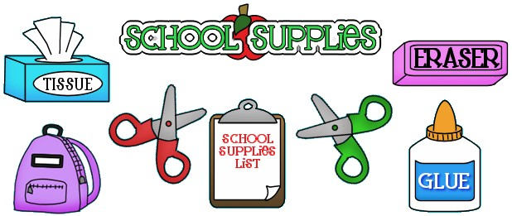

2- Bottles of Hand Sanitizer

2- Bottles of Hand Soap

4- Boxes of Kleenex (or pocket size Kleenex)

2- Boxes of 1 Gallon Ziploc Bags

1- Box of Sandwich size Ziploc Bags

4- Rolls of Paper Towel

2- Packs of Baby Wipes

1- Pack of Paper Plates

1- Pack of Variety Flatware

1- Pack of Cups 24ct.

1- Set of Change of Clothes:

Shirt

Underwear

Pants

Socks

1- Box of Garbage Bags

1- Child size Blanket (Full day only)

1- Large Book bag (no wheels)

1- Clorox Anywhere Spray / Wipes

1- Box of Latex-free Rubber Gloves

- Face Masks Disposable or Reusable

- Headphones

***\*Please write child’s name on ALL clothing and supplies!***

***\*All Teachers will have supply baskets for students.***

***\*REPLACMENT of supplies during the year is the student’s responsibility.***